**Argenis Jimenez Aguirre**

**CPE 403**

**CC1350 LAB 1**

Task 00

Tested “hello world” code.

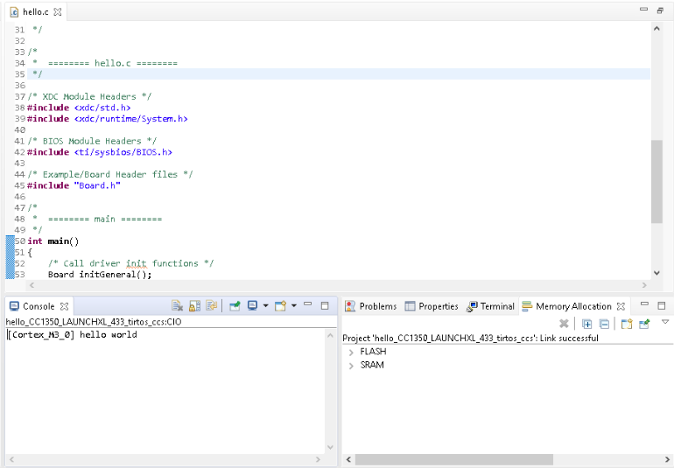

Task 01

Replaced “hello world” code for blinking LED code.

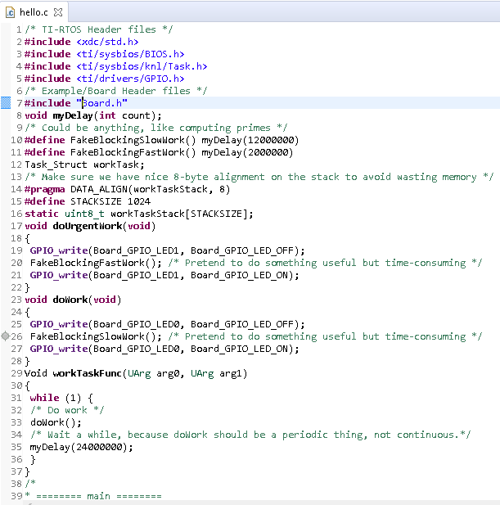

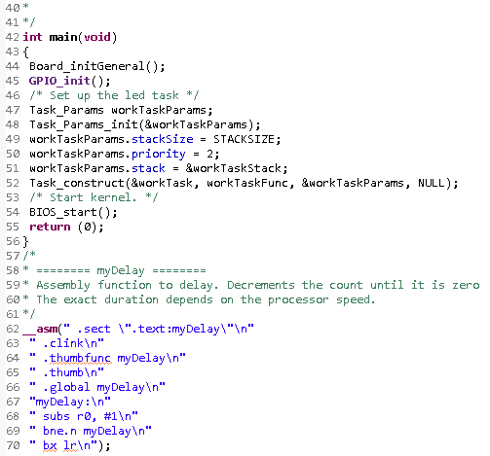

Task 02

Obtained snapshot of the whole RTOS.

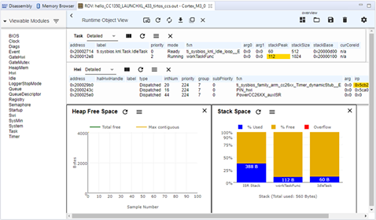

Modified hello.cfg file.

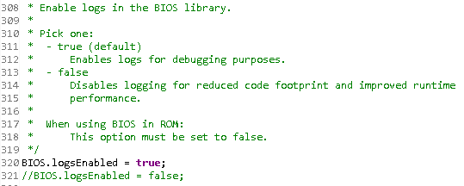

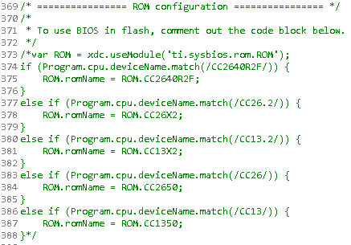

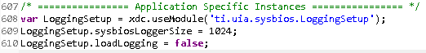

Obtained Execution Graph.

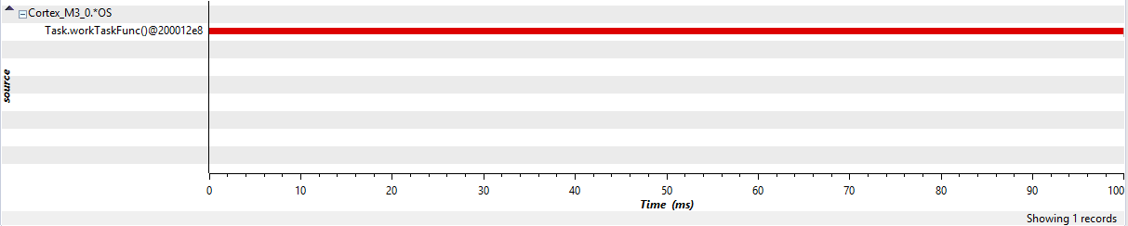

Task 03

Priority list and execution graph.

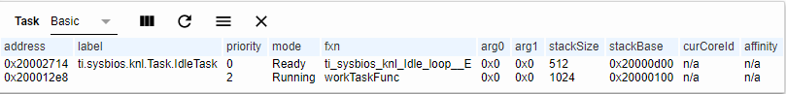

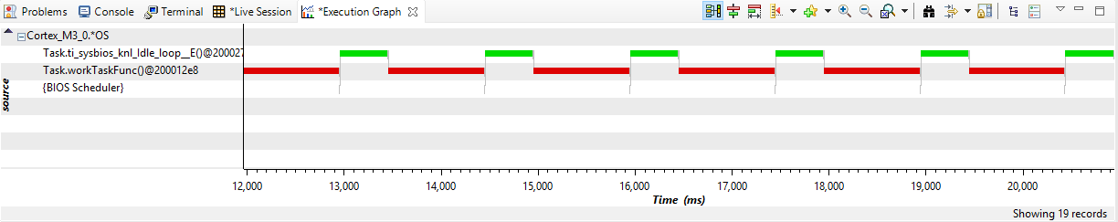

Task04

UrgentWork priority = 1 and execution graph.

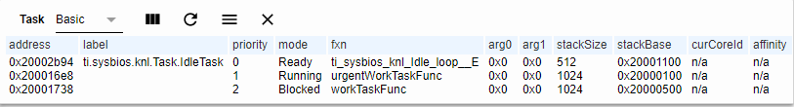

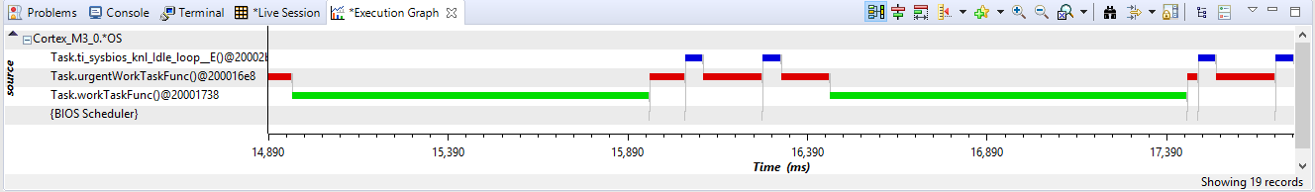

UrgentWork priority = 3 and execution graph.

